

Disclosure Plan Template

Prepared by [insert name of author]

Disclosure Plan Template

Introduction 3

Privacy 4

Container 4

Timelines 5

Records 6

Washrooms 8

Time Off 9

Appointments 9

Sick Leave 9

Communications 10

Education 11

Follow-up 12

Sample Emails 13

Sent by Employee 13

Sent by Manager or Human Resources 13

Introduction

This document is intended to summarize the key information and plans for supporting the employee, [insert chosen name] with [insert info] pronouns (formerly known as [insert legal or birth name]), in sharing a new first name and pronouns at University of British Columbia, including the logistics and communications to different stakeholders.

[Insert employee name] is employed within the [insert info] team/department and works across [insert info] locations.

The Disclosure Plan is intended to be an employee-led process with Human Resource Representatives, as identified by the Support Team, providing support as is reasonable and possible. The immediate Support Team includes:

* [Insert name and title]
* [Insert name and title]
* [Insert name and title]

As detailed in this document, the above-identified Support Team supports the employee with the disclosure process and coordinates administrative aspects. As indicated in the outset of this document, other members of human resources may also be involved to provide further support.

This document is a living document to guide and capture the relevant information required for the employee and those on the identified Support Team. The intention is for this document to be reviewed, confirmed, and revisited by the Support Team and the employee in one (1), three (3), and six (6) months to update any important and relevant information, and to reflect on what has worked and what requires further discussion or a change in strategy or support.

Privacy

The employee has indicated that [insert pronouns] is/are okay to share personal information pertaining to [insert details to share with others at UBC], particularly, in response to colleagues' questions. However, it is important to recognize that this is [insert chosen name]’s story to tell and managers or others should refrain from sharing any personal or private details.

The employee has also indicated that [insert chosen name] feels comfortable to address any appropriate questions raised by co-workers. In instances that extend beyond [insert chosen name]’s comfort zone or may constitute harassment, [insert chosen name] will reach out directly to [insert member of Support Team] to explore options for next steps, including strategies and responses.

|  |
| --- |
| Container  Level of information to be shared with others at work includes the following details:  **New name:** [insert info]  **New pronouns:** [insert info]  **Other information:**[insert info]  The effort of colleagues toward using the correct new name and pronoun is important. |

Timelines

The employee began to shareintent to disclose their new name and pronouns within the workplace to their manager/supervisor on [insert date], Equity and Inclusion Office on [insert date], and Human Resources on[insert date]. On [insert date], the first meeting was held by the employee, the Support Team, and [insert other stakeholders].

The employee will be away from work starting [insert date] and returning to work in [insert date]. The request is to return to work on [insert date] using the new name and pronouns in the workplace.

The following is a high-level timeline with key milestone dates.

| Date | Description of Milestones |
| --- | --- |
| **[insert date]** | Employee expressed intention to share the new name and pronouns with [insert pronoun] team via [insert method]. |
| **[insert date]** | [Insert chosen name] also indicated [insert pronoun] is okay with colleagues asking questions of [insert info] directly, including within the period of absence. |
| **[insert date]** | [Insert chosen name] on leave of absence. The exact return date is [insert date]. |
| **[insert date]** | [Insert member of Support Team] to check in with employee within [insert duration - # of days or weeks] of email announcement, and at minimum one additional time prior to return to work |
| **[insert date]** | Support Team to coordinate updates of the new name within personnel and administrative systems |
| **[insert date]** | Support Team to explore and coordinate the installation of [insert info] |
| **[insert date]** | Support Team to assess and agree on the need for information and education sessions for supervisors, managers and other personnel |
| **[insert date]** | Employee returns to work with new name and pronouns |

Records

Effective [insert date], the employee will begin using new first name and/or pronouns in the workplace. Several places across UBC’s systems will need to be updated before [insert date] to support this disclosure of new first name and/or pronouns.

The employee indicated the intent to make a legal name change. It is uncertain at this time when the legal change of name will be complete, as the process can be a lengthy one. In the interim, there will be some places, such as payroll, where the legal name will continue to be required, until legal change of name documentation can be provided. Only [insert type of role] staff will have access to this information to ensure the legal name is used and known as little as possible.

Due to the highly personal and confidential nature of this disclosure of new name and pronouns, it is recommended to develop a strategy for informing any key units necessary to make changes within the various systems, such as an accompanying message to provide context, as necessary, that is co-crafted by the employee and the support team.

The following table begins to list some of the places where updates with the new name are required. Further discussions among the Support Team are required to build out a comprehensive and complete list.

Despite best intentions and efforts at UBC, there are many systems at UBC that do not always communicate well together. As such, it is important establish a plan if the employee receives communications or encounters a system that does not use their chosen name. It is recommended that the employee inform their manager and/or reach out to the Equity and Inclusion Office’s inbox [trans.inclusion@equity.ubc.ca](mailto:trans.inclusion@equity.ubc.ca) to determine what options are available to resolve the matter(s).

| Item to Update | Name to Update | Gender Marker | Lead Person | Deadline | Status |
| --- | --- | --- | --- | --- | --- |
| **Human Resources Self-Serve Record (Workday)** | [Insert chosen or legal name] | [Insert yes or no] |  |  |  |
| **UBC Card** |  |  |  |  |  |
| **Security Badge** |  |  |  |  |  |
| **Email Address** |  |  |  |  |  |
| **Faculty Service Centre (if instructor)** |  |  |  |  |  |
| **Desk/Office Door** |  |  |  |  |  |
| **Voicemail and Phone Display Name** |  |  |  |  |  |
| **Payroll (only once legal name + gender change made)** |  |  |  |  |  |
| **Update criminal records check to new legal name (if required for UBC position)** |  |  |  |  |  |
| **Extended health care and benefits** |  |  |  |  |  |
| **Faculty/Staff Directory** |  |  |  |  |  |
| **Business Cards** |  |  |  |  |  |
| **Organization Charts** |  |  |  |  |  |
| **Names and/or photos on dept/unit websites** |  |  |  |  |  |
| **Professional Licenses, Qualifications, Accreditations** |  |  |  |  |  |
| **Publication Authorship** |  |  |  |  |  |
| **Name on Patent(s)** |  |  |  |  |  |
| **Contact/Professional Mailing Lists** |  |  |  |  |  |
| **Ask Colleagues to Delete Former Contact Profiles** |  |  |  |  |  |

Washrooms

As per legal precedence in British Columbia, and as supported by the BC Human Rights Code, all individuals have the right to access the washroom and change room facilities that align with their self-determined gender identity without the need for changes to government identification and/or medical transition.

Currently, there are [insert number] washrooms in [insert info] locations that the employee can readily access and is comfortable to use.

The employee expressed the concern that facility users may stare or comment while [insert pronoun and verb] the washrooms. If this happens, [insert pronoun] will notify [Support Team member] to develop strategies for next steps. This topic will also be raised during follow-up meetings to ensure

The employee volunteered additional information about using the [insert type] washrooms for an interim period. Over time, [insert pronoun] would like to begin to use the [insert type] washrooms and/or locker room.

Time Off

If the employee requires any time off, polices regarding leaves of absence, sick time, medical appointments, and others can be found here:

Appointments

Some UBC employment groups are eligible for paid time off for medical appointments during working hours. For more information, visit the [Human Resources Workplace Wellbeing and Benefits Leaves](http://www.hr.ubc.ca/wellbeing-benefits/benefits/details/vacation-leaves/) page.

Cultural Practices

Cultural responsibilities for Two-Spirit employees may include the need to connect with their families and/or communities to participate in ceremony and cultural practice.. For more information about specific types of time off, visit the [Human Resources Workplace Wellbeing and Benefits Leaves](http://www.hr.ubc.ca/wellbeing-benefits/benefits/details/vacation-leaves/) page.

Healing and Recovery

Faculty and staff are eligible for paid time off with benefits for gender affirming surgery and post-surgery, however the length of time eligible depends on the employee’s membership within UBC employment groups. For more information, visit the [Human Resources Workplace Wellbeing and Benefits Leaves](https://hr.ubc.ca/benefits/benefit-plan-details/vacation-leaves) page.

In the event that the employee is medically-required to be off work for more than six months (four months for CUPE 2950), the employee should make an application to the [UBC Disability Benefits Plan](http://www.hr.ubc.ca/wellbeing-benefits/benefits/details/income-replacement-disability-benefits/) (for Staff) or the [Income Replacement Plan](http://www.hr.ubc.ca/wellbeing-benefits/benefits/details/income-replacement-disability-benefits/) (for Faculty). These plans provide a monthly income if the employees cannot work for an extended period due to illness or injury.

The following is a high-level summary of the employee’s need for upcoming time off.

| Date | Description of Time Off |
| --- | --- |
| **[insert date range]** | [Insert chosen name] is on medical leave of absence. The exact return date is [insert date]. |
| **[insert date range]** | Employee plans to go to weekly appointments related to gender-affirming care. Regular process for covering medical appointments will be followed. |
| **[insert date range]** | Employee plans to attend to cultural matters on a bimonthly basis. Regular process for covering cultural events will be followed. |
|  | Or state: “N/A – The employee does not have current needs for time off. This will be revisited during future update meetings.” |

Communications

As others at UBC will need to be updated with the employee’s new name and pronoun, the communications plan maps out what level of information is needed, for which stakeholder groups, as told by whom, how and when. The sequencing of these communications is also important to consider and should be done in collaboration with the disclosing employee. Figure 1 provides a visual of the various stakeholder groups.

Figure 1—Levels of Information by Stakeholder Group

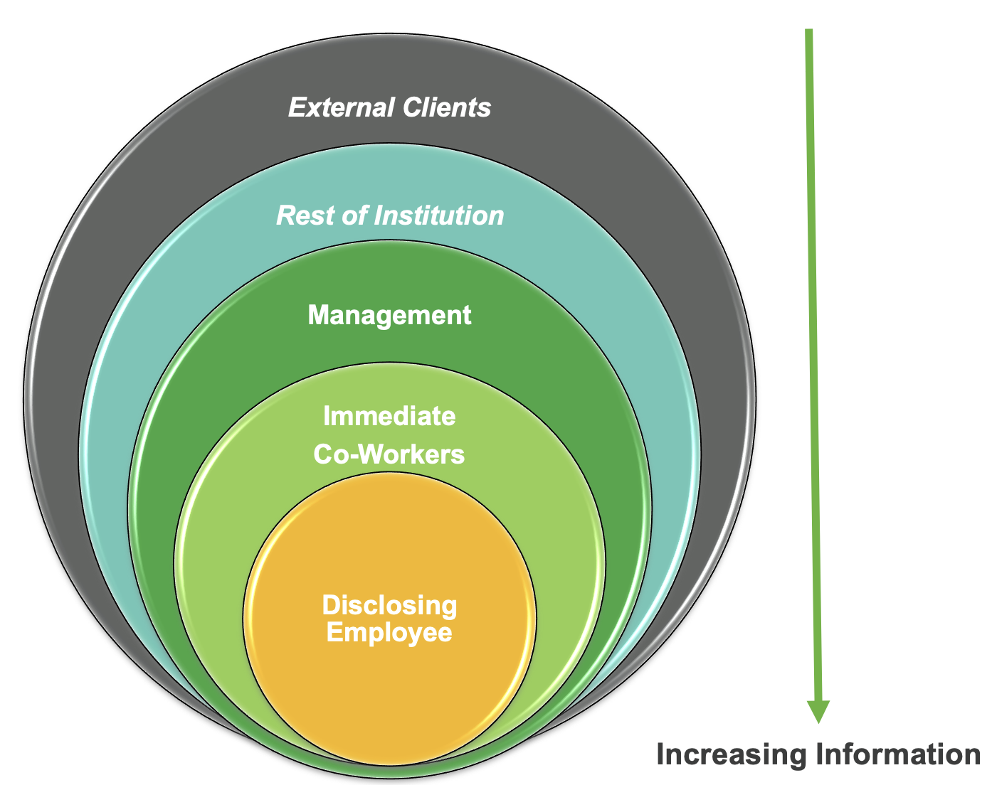

The stakeholder groups with whom certain levels of information will be shared are listed in the table below along with timelines.

| Stakeholder Group | Key Message / Information | Lead Person | Timeline |
| --- | --- | --- | --- |
| **Managers/Supervisors** |  |  |  |
| **Immediate Team Members** |  |  |  |
| **Students (if instructors)** |  |  |  |
| **Others?** |  |  |  |

Education

Part of the plan is to consider and identify which stakeholder groups might benefit from information and education opportunities to deepen their knowledge and understanding of gender identity and gender expression in the workplace. Supervisors and managers may benefit from information and education sessions.

Information and education sessions will be tailored to meet the needs of the group (i.e., pertaining to the group’s role and function) and typically include:

* An overview of the concepts and terminology of gender identity and expression
* Understanding the employer’s responsibility pertaining to gender identity and expression as protected grounds in the Canadian Human Rights Act
* How leaders/managers can foster and support a gender inclusive workplace
* How leaders/managers can best support the disclosing employee

The following table summarizes the plans for providing education at various levels.

| Stakeholder Group | Title and Key Content | Facilitator(s) | Timeline |
| --- | --- | --- | --- |
| **Managers/Supervisors** |  |  |  |
| **Immediate Team Members** |  |  |  |
| **Students (if instructor)** |  |  |  |
| **Others?** |  |  |  |

Follow-up

The Support Team will follow-up with the disclosing employee within 1 to 2 weeks of disclosure. The purpose of the follow-up meetings is to discuss how the communication and education strategies went and address any issues, where they arise.

In addition, the Support Team should follow-up in one, three, and six months after the employee’s return to work date to discuss how the disclosure at work is going, and to reflect on what has worked and what requires further discussion or a change in strategy or support.

The Support Team is available to connect and resolve any issues as they arise.

| Date | Lead Person | Description of Follow-Up | Status |
| --- | --- | --- | --- |
| **[insert date]**  1-2 weeks after disclosing | **[insert name]** | Discuss how announcement went and any immediately arising issues. | [Insert completed or pending] |
| **[insert date]**  1 month after disclosing | **[insert name]** | Discuss how disclosure is going, any challenges, and how to address | [Insert completed or pending] |
| **[insert date]**  3 months after disclosing | **[insert name]** | Discuss how disclosure is going, any challenges, and how to address | [Insert completed or pending] |
| **[insert date]**  6 months after disclosing | **[insert name]** | Discuss how disclosure is going, any challenges, and how to address | [Insert completed or pending] |

Sample Emails

Sent by Employee

This is an example of a disclosing employee choosing email as a route to share their news to a wider group of co-workers, after sharing with this employee’s immediate unit:

*Hello and Happy New Year everybody!*

*As part of a fresh start on the year, I’ve decided to make a personal commitment on bringing my authentic self to work. For about 3 years now, I’ve been actively bringing awareness around my gender identity and pronoun usage in my personal life, and this year I hope to do the same at work. Any support from the team is much appreciated! So, without further ado … here it is:*

*I identify as trans or specifically trans-masculine, and do not use any pronouns (i.e., no she, he, or they). I only use my name. Although starting to use a new pronoun (or in this case, no pronouns) to refer to someone sounds like a really simple request, it’s definitely not easy! I do not expect everybody to get it right the first time, and I won’t be offended with any unintentional slips! However, during a call or on email or on IM, I may quickly point out any incorrect pronoun usage (with the words “no pronouns!”). That’s just meant to bring awareness and quick acknowledgement around the incorrect usage and is not at all meant to refocus the discussion at hand.*

*I know this is a lot to take in, so I have included some video resources that you can use for reference, but please feel free to reach out to me directly if you have any questions.*

*Thank you in advance for your support! It really means a lot to me.*

Sent by Manager or Human Resources

This example email is from the Supervisor/Manager or Human Resources Representative:

*One of our employees, formerly known as* [insert legal or birth name]*, has changed* [insert pronoun] *name to* [Insert chosen name] *and pronouns of* [insert pronoun]*. The change is effective immediately.  Please join me in supporting and welcoming* [insert pronoun]*. We recognize that it may take a few tries to get the new name and pronouns, and we know with intentional practice, we will get there together.* *Please direct all future email correspondence to* [insert new e-mail address]*.* [Insert chosen name]*‘s phone number remains the same.*

*If there are any questions or issues, please feel to direct them to Supervisor/Manager or Human Resources Representative* [insert new e-mail address] *and/or review the following resources.*